# DIS-Asia- Indus Valley-Tel Halaf - 6000 B.C.E.-Terracotta- House Fertility Idol

# Indus Valley Tel Halaf 6000 B.C.E. Terracotta House Fertility Idol. **53.09 gm.; height 75.45 mm. Lightly Brushed Only. VF+ Condition, Light Baking Cracks.**

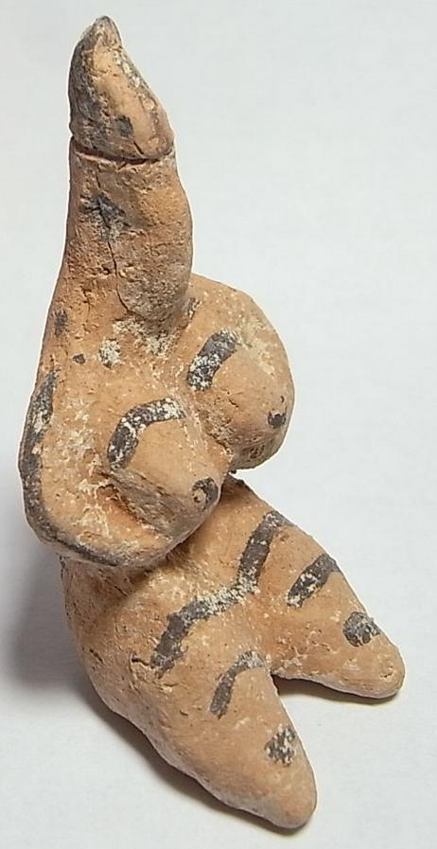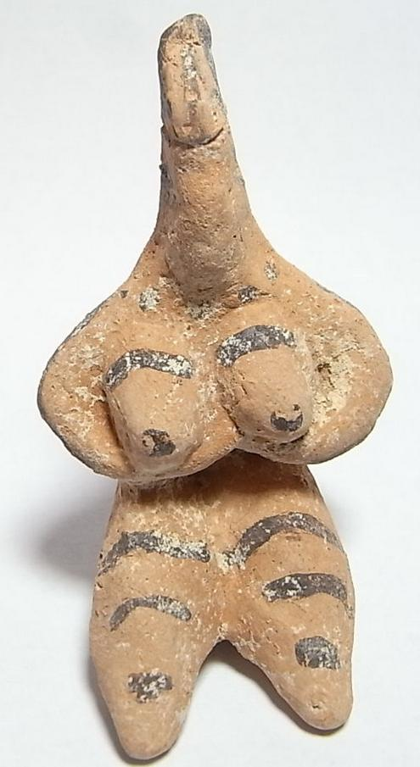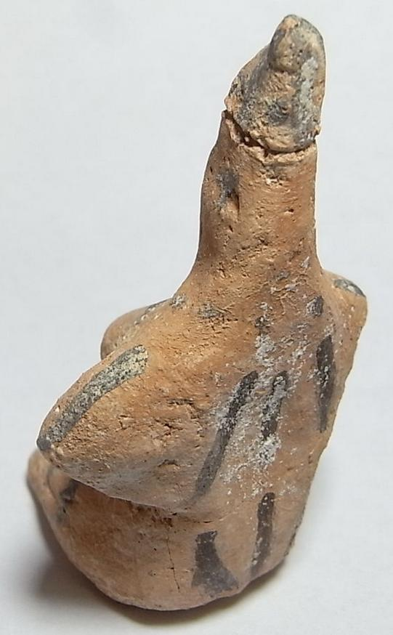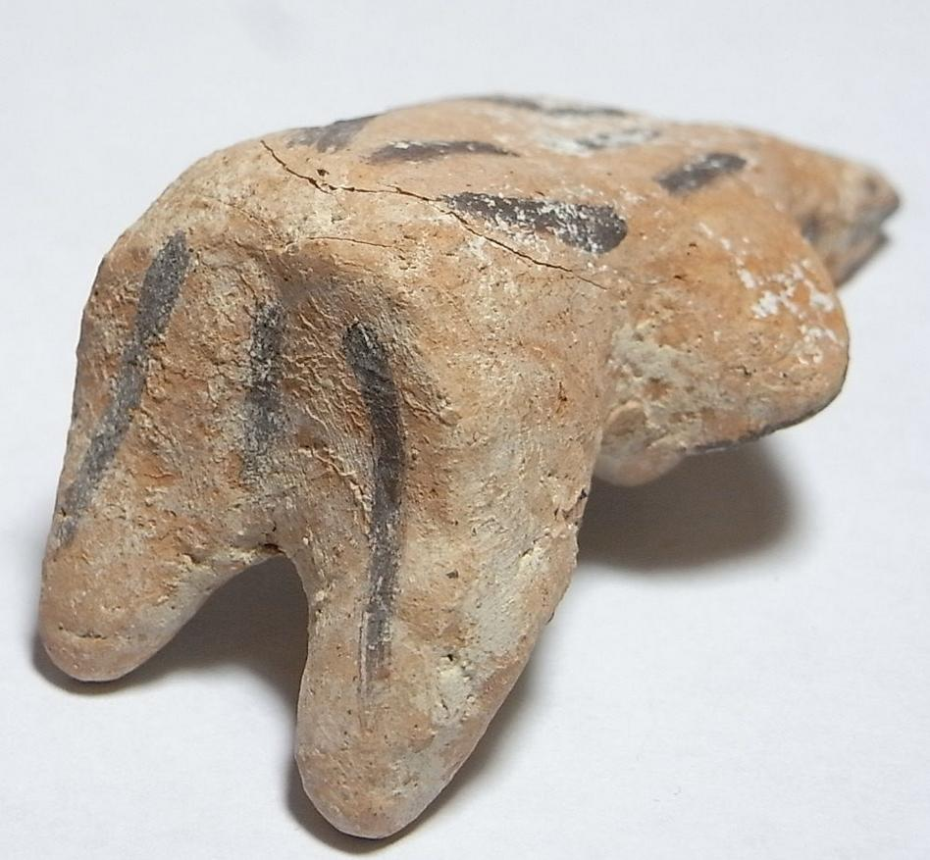

Sold by [meridian-coins-s...](http://myworld.ebay.com/meridian-coins-sussex-uk) ( [2033](http://feedback.ebay.com/ws/eBayISAPI.dll?ViewFeedback&userid=meridian-coins-sussex-uk) )

### Delivery package 1 of 1

Estimated delivery Monday, Jan 25, 2016 - Tuesday, Feb 2, 2016

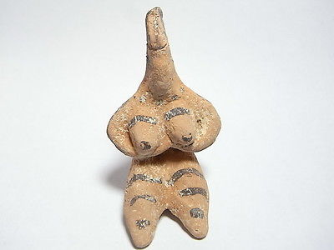

#### [Ancient Indus Valley Tel Halaf 6000 BC Terracotta House Fertility Idol. (A829B)](http://www.ebay.com/itm/172042644865)

|  |  |
| --- | --- |
| Item price | GBP 100.00 |
| Quantity | 1 |
| Item number | 172042644865 |
| Shipping service | Royal Mail International Signed |

## Shipping address

Ralph J Coffman Jr

149 Atlantic Ave

Swampscott MA 01907-2427

United States

## Order total

|  |  |
| --- | --- |
| Subtotal | GBP 100.00 |
| Shipping | GBP 7.20 |

**Total**

GBP 107.20

Order placed on

Sunday, Jan 17, 2016

Payment method

PayPal

Payment date

Sunday, Jan 17, 2016